Students Conceptual Understanding of Logic Material in Terms of Assessment Diagnostic Result

Zahra Nugraheni^{1*}, Sofwan Hadi²
^{1,2}Mathematics Education Departement, State Islamic Institute of Ponorogo,
*Corresponding author. Jl. Pramuka, Ponorogo 63471, Indonesia
 | E-mail: | nugraheni@iainponorogo.ac.id ^{1*)}  sofwan@iainponorogo.ac.id ²
Keywords | ABSTRACT
Pemahaman Konseptual Matematis, Kecakapan Matematis, Logika | Kecakapan matematis merupakan salah satu acuan dalam kesuksesan belajar matematika. Salah satu komponen kecakapan matematis adalah Pemahaman Konseptual Matematis, dengan 6 indikator pemahaman konsep. Penelitian ini merupakan penelitian deskriptif kuantitatif dan kemudian dilanjutkan dengan analisis jawaban mahasiswa. Subjek penelitian sebanyak 44 mahasiswa Pendidikan Matematika angkatan pertama IAIN Ponorogo Tahun Akademik 2022-2023. Penelitian ini berfokus untuk menganalisis pemahaman konseptual mahasiswa pada materi logika ditinjau dari hasil assessment diagnostic terkait asal jurusan pada jenjang pendidikan sebelumnya. Data diperoleh dari nilai dan jawaban mahasiswa pada soal Pemahaman Konseptual materi Logika. Berdasarkan hasil analisis, pemahaman konseptual mahasiswa Tadris Matematika IAIN Ponorogo pada materi logika masih tergolong rendah. Hal ini ditunjukkan dengan rerata persentase pada masing-masing asal jurusan masih berada di bawah 70%. Adapun rincian rerata persentase pemahaman konseptual mahasiswa dari asal jurusan IPA sebesar 52,3%, mahasiswa dari asal jurusan IPS 43,3%, serta mahasiswa dari asal jurusan Agama dan kejuruan masing-masing 33,3%. Dari hasil analisis jawaban mahasiswa, pada masing-masing indikator pemahaman konseptual matematis, kesalahan yang paling banyak dilakukan mahasiswa adalah pada indikator keenam yaitu mengembangkan syarat perlu atau cukup dari suatu konsep, yakni hanya 2 dari seluruh mahasiswa mampu menjawab benar.
Mathematical Conceptual Understanding, Mathematical Proficiency, Logic | Mathematical proficiency is one of the treatises to indicate the success of learning mathematics. One component of mathematical proficiency is Mathematical Conceptual Understanding, with 6 indicators of it. This is descriptive quantitative research and continued with answer analysis of 44 Mathematics Education students of the first batch at IAIN Ponorogo in the Academic Year 2022-2023. This study focuses on analyzing descriptively students' conceptual understanding of logic in term diagnostic assessment results i.e. students' majors at the previous education level. Data were obtained from the students' scores and answers to Logic material. Based on the results, known that the conceptual understanding of students is still relatively low as it is below 70%. For details, the average student's conceptual understanding percentage from science majors is 52.3%, social sciences majors are 43.3%, and religion and vocational majors are 33.3%. The common mistakes that students made were in the sixth indicator, i.e. developing necessary or sufficient terms of a concept which only 2 of all students answered correctly.

INTRODUCTION
Mathematics is a basic science which is also called the mother of science. This is because mathematics has an important role and is closely related to various scientific disciplines. Mathematics is also the basis for technological development and it can improve human reasoning power. Therefore, mathematics is always taught at every education level, from elementary school to university level.
Compared with other scientific disciplines, mathematics has different characteristics. Viewed from the objects studied, mathematics studies direct and indirect objects. Direct objects relate to the content of the mathematical material itself, and indirect objects relate to mental processes that occur in thinking activities, including abilities in problem-solving, logical, critical, systematic, and creative thinking. Overall, mathematics has stages of learning (Ababil & Septianawati, 2021). Hierarchically, mathematics learning at higher levels is more formal and abstract when compared to mathematics learning at lower levels (Ernest et al., 2016). Therefore, studying mathematics at the university level also requires high mathematical skills.
Mathematical proficiency is a treatise on achieving success in learning mathematics. Furthermore, mathematical proficiency consists of (1) conceptual understanding, (2) procedural fluency, (3) strategic competence, (4) adaptive reasoning, and (5) productive disposition (Barham, 2020; Corrêa & Haslam, 2020; Irawan, 2018; Sudiarta & Widana, 2019).
Mathematical conceptual understanding includes understanding Ma-thematical concepts, operations, and relationships (Irawan, 2018; Nugraheni et al., 2018b, 2018a; Wahyuni ​​& Kharimah, 2017). Furthermore, conceptual understanding is a skill related to the mathematical conceptualize ability, which includes mathematical operations, mathematical representations, and mathematical relations i.e linking between concepts and developing a concept (Corrêa & Haslam, 2020; Kholid et al., 2021; Nugraheni et al., 2018b). These sources indicate that the Indicators of mathematical conceptual understanding include: (1) carrying out mathematical operations related to a particular concept, (2) classifying an object based on whether or not the requirements of a concept, (3) providing examples or non-examples of a concept, (4) representing a concept into different ways, (5) connecting related concepts, (6) developing necessary or sufficient conditions for a concept (Corrêa & Haslam, 2020; Kholid et al., 2021; Nugraheni et al., 2018b).
Another source explains that mathematical conceptual understanding is a basic mathematical ability because this ability absolutely must be possessed by students to be able to solve mathematical problems. The indicators of conceptual understanding related to this source are: (1) thinking procedurally/algorithmically, and (2) linking a concept with other concepts (Wahyuni ​​& Kharimah, 2017).
Students' difficulties in studying mathematics at the college level are caused by the weakness of their conceptual understanding (Karim & Nurrahmah, 2018; Lubis et al., 2021; Musyadad, 2021). In fact, mathematical concepts in higher education are more complex and complicated. Complex because it is interconnected with other concepts. It is complicated because of it uses many symbols and meanings (Hanifah & Abadi, 2018). Furthermore, this source indicates to understand mathematical concepts, a person must be able to: (1) understand the meaning of the symbols in the concept, (2) master the previous concept, (3) relate the concept to the concept being studied (Hanifah & Abadi, 2018).
Based on the results of the research by Gusmania & Agustyaningrum which analyzed understanding of mathematical concepts in trigonometry courses, it was stated that students' understanding of concepts was still relatively low (Gusmania & Agustyaningrum, 2020). Gusmania and Agustyaningrum's (2020) research examines 4 indicators of concept understanding, including: restating a concept, (2) presenting the concept in a mathematically representative form, (3) selecting and using certain procedures/operations, (4) applying the concept/ algorithms in problem-solving. The lowest percentage is found in the second indicator at 40.09%. Thus, it can be said that students' mathematical conceptual understanding is still considered low. The research results of Gusmania and Ayustyaningrum (2020) are also in line with the previous research i.e Hayati & Asmara, 2021; Hoiriyah, 2019; Karim & Nurrahmah, 2018; Rismawati & Hutagaol, 2018; Wahyuni ​​& Kharimah, 2017.
Logic material is one of the materials that is studied in the Introduction to Basic Mathematics course. Basically, in logic material, students learn the principles of correct reasoning (Karso, 2014). Furthermore, logic as a term is a technique, strategy, method, or approach that is related to accuracy in reasoning. Logic equips students with a logical, systematic, and principled line of thinking. Logic is also the basis for the flow of thinking in carrying out proof. Therefore, logic is very important to be mastered by students as the material that is learned in logic material will become the basis for thinking correctly (Romadiastri, 2016). In studying logical concepts, students are required to always have good learning readiness in addition to requiring high reasoning power (Anugrahana, 2020). This causes logic material to be seen as a difficult concept to be learned.
Mathematics Education is a new study program at the Education Department of IAIN Ponorogo. Mathematics Education was established in the Academic Year 2022 – 2023 and received 2 classes in the first batch, each class consisting of 22 students. Then, the total number of Mathematics Education IAIN Ponorogo students in the first batch was 44 students. Based on the results of documentation regarding educational background, it is known that Mathematics Education IAIN Ponorogo students come from various educational backgrounds, including SMA, MA, and SMK. These students also come from various majors, such as Natural Sciences, Social Sciences, Religion, and Vocational education. Considering that the basic competencies and coverage of material taught in mathematics subjects are different in each major of the Middle School Level, it results in the prior knowledge of Mathematics Education students becoming more varied (Parhaini, 2017). Furthermore, this diversity is also considered to influence the differences in students' mathematical conceptual understanding. Based on this description, this research will analyze the mathematical conceptual understanding of students in the first semester of Mathematics Education IAIN Ponorogo in logic material. The analysis is carried out by considering the student's major at the previous education level.
The conceptual understanding indicators used in this research refer to the conceptual understanding indicators in the research of (Nugraheni et al., 2018b) which consist of (1) performing mathematical operations related to a certain concept, (2) classifying an object based on whether it is fulfilled or not. requirements of a concept, (3) providing examples or non-examples of a concept, (4) representing a concept in different ways, (5) connecting related concepts, (6) developing necessary or sufficient requirements for a concept. The distribution of questions for each indicator is shown in Table 1.

METHODS
This is descriptive quantitative research with 44 students of Mathematics Education IAIN Ponorogo as subjects. They were students in the first semester of the Academic Year 2022 - 2023 and were currently taking the Basic Introduction to Mathematics course. This research aims to quantitatively describe students' mathematical conceptual understanding which includes: average scores, maximum and minimum scores, also the percentage of achievement for each indicator in terms of the student's major of previous education level. After the quantitative description of the data was obtained, then analyzed the students' answers to the logic material. The analysis of answers was limited to student answers to provide deeper information regarding each indicator of conceptual understanding.

RESULT AND DISCUSSION
Based on data collection regarding the majors at the Middle School level, we obtained that of 44 Mathematics education students, about 12 students (27.3%) came from SMA, 30 students (68.2%) came from MA, and 2 students (4.5%) came from vocational school. The results of this analysis are shown in Table 2.

Table 1. Distribution of Indicators on Question Items
Indicator | Question items
Performing mathematical operations related to a certain concept | Negate and simplify the following statements!  - $∀x,\left[p\left(x\right)→q(x)\right]$  - $∃x,\left[p(x)∨q(x)\right]$  - $∀x,\left[p\left(x\right)∧∼q(x)\right]$  - $∃x,\left[\left(p\left(x\right)∧q\left(x\right)\right)→r(x)\right]$
Classifying an object based on whether or not the requirements of a concept are fulfilled | Determine whether the following sentence is a statement or not!  - 1,000,000,000 is a very large number.  - President Jokowi is the 5th President of the Republic of Indonesia.  - There is no largest number.
Providing examples or non-examples of a concept | Let p, q, and r be statements about triangle ABC.  p: Triangle ABC isosceles  q: Triangle ABC is equilateral  Translate:  - $p→q$ ,  - (b) $\sim q→\sim p$,  - (c) $\sim p∨q$
Representing a concept in different ways | Prove that $\left[(p∨q)∧∼p\right]→q$ is a tautology!  If (a) is a tautology, does it also mean that $\left[(p∨q)∧∼p\right]⇒q$
Connecting related concepts | Prove that:  $$(p∧q)⇔p∧(∼p∨q)$$  $$p⇔(p∧q)∨(p∧∼q)$$  $$\left(p∨q\right)→r⇔(p→r)∧(q→r)$$  $$∼\left[p∨\left(q∧r\right)\right]⇔(∼p∧∼q)∨(∼p∧∼r)$$
Developing necessary or sufficient conditions for a concept | Is the following argument valid? If valid, identify which inference rule is used!  I will become famous or I will become a preacher.  I will not become a preacher.  ∴ I will become famous.  If the sun shines brightly, then John must be happy.  It turns out John wasn't happy  ∴ The sun does not shine brightly.  If I am an outstanding student, then I will graduate.  However, I am not an outstanding student.  ∴ I didn't graduate.

Table 2. Distribution of Student Data Regarding School of Previous Education Level
Kind of Middle School | Number of Students | Percentage (%)
SMA | 12 | 27,3
MA | 30 | 68,2
SMK | 2 | 4,5

Based on the table above, it can be seen that most of the Mathematics Education students in the academic year 2022/2023 came from Madrasah Aliah (MA), then came from SMA, and the least came from SMK.
Furthermore, from data collection related to education background, the results obtained that 35 students (79.54%) came from the Natural Science Major 5 students (11.36%) came from the Social Sciences Major, 2 students (4.54%) came from the Religion Major, and 2 students (4.54%) came from vocational schools. The results of the analysis related to the major are shown in Table 3.

Table 3. Distribution of student data related to majors
Major in Previous Education Level | Number of Students | Percentage (%)
Natural Science | 35 | 79,54
Social Science | 5 | 11,36
Religion Department | 2 | 4,54
Vocational School | 2 | 4,54

Based on Table 3, it can be seen that among 44 students in Mathematics Education, 35 students were from the science major, and the other 9 were from non-science majors. Then, the distribution of student scores in working on questions related to logic in each major is shown in Table 4.

Table 4. Distribution of Students’ Scores in Logic Material
Major of Students | Number of students | Maximum score | Minimum score | Score Average
Natural Science | 35 | 95 | 7 | 69,83
Social Science | 5 | 76 | 53 | 67,2
Religion Dept | 2 | 71 | 46 | 58,5
Vocational Dept | 2 | 69 | 44 | 57
Rerata total |  |  |  | 63,13

Based on Table 4, it can be seen that the average student score is still relatively low with a total average of 63.13.
Then, the percentage of achievement in each indicator of mathematical conceptual understanding for each student's major is shown in Table 5.

Table 5. Percentage of Students Answering Correctly for Each Conceptual Understanding Indicator
Conceptual Understanding Indicator | Percentage of Indicator Achievement for Each Department in Previous Education Level (%) |  |  |  | The Average percentage of achievement per indicator (%)
 | Natural Science | Social Science | Religion Dept | Vocational Dept
Performing mathematical operations related to a certain concept | 43 | 40 | 50 | 50 | 45,75
Classifying an object based on whether or not the requirements of a concept are fulfilled | 37 | 60 | 0 | 50 | 36,75
Providing examples or non-examples of a concept | 51 | 40 | 50 | 0 | 35,25
Representing a concept in different ways | 100 | 60 | 50 | 50 | 65
Connecting related concepts | 83 | 60 | 50 | 50 | 60,75
Developing necessary or sufficient conditions for a concept | 6 | 0 | 0 | 0 | 1,5
Average percentage of achievement of concept understanding indicators in each department (%) | 52,3 | 43,3 | 33,3 | 33,3

Based on Table 5, seen from the major at the middle school level it is known that the average percentage of achievement for students’ conceptual understanding indicator in logic material is still below 70%, with details: (1) students from the science major are 52.3%, (2) students from the Social Sciences major 43.3%, and (3) students from the Religion and vocational majors 33.3%. Thus, based on quantitative descriptive analysis, it was found that Mathematics Education students' conceptual understanding was relatively low.
Seeing from each indicator of conceptual understanding, obtained some facts related to each indicator achievement i.e: (1) in indicator 1, the average percentage of achievement is 45.75%, (2) in indicator 2 it is 36.75%, (3) in indicator 3 is 35.25%, (4) indicator 4 is 65%, (5) indicator 5 is 60.75%, and (6) indicator 6 is 1.5%.
Furthermore, to gain deeper findings regarding student answers, an analysis of student answer sheets was carried out in terms of middle school major for each indicator. In the first indicator, i.e. performing mathematical operations related to a concept related to logical operations, 15 students from the Natural Science major answered correctly, while 20 students answered incorrectly. Of students from the Social Sciences major, 2 students answered correctly, 1 student answered incorrectly, and 2 students did not answer. In the group of students from the Religion and Vocational major, 1 student answered correctly for each major, and the others did not answer. From all the answers (right or wrong), it appears that students have understood the concept of negation for quantifiers, both universal and existential quantifiers. This is shown by the accuracy of all students' answers in showing the negation of each quantifier given. However, the mistakes that most students make are in the procedures for carrying out negation operations for other forms that accompany quantifiers. Common mistakes were made in points (a) and (d), which did not change the form of implication into another form of equivalent statement to the form of implication (e.g. by using Switcheroo's Law) so that the negation operation could be carried out. Of course, this would have an impact on the next work steps. Figure 1 shows one of the results of the work of a student who made an operation error.
In Figure 1, it appears that students did not change the form of implication into another equivalent form before denying (see Q1). This Q1 error was the most common mistake made by students who answered incorrectly. Then, the second mistake that students made was directly negating $p(x)$ and $q(x)$so that the results $\sim p(\sim x)$ and $\sim q(\sim x)$ were obtained (see Q2). This was not by the concept of negation of a compound statement. Then, the form $\sim p(\sim x)$ was operated to obtain the result $\sim p(x)$based on double negation. This was not a concept of double negation (see Q3).

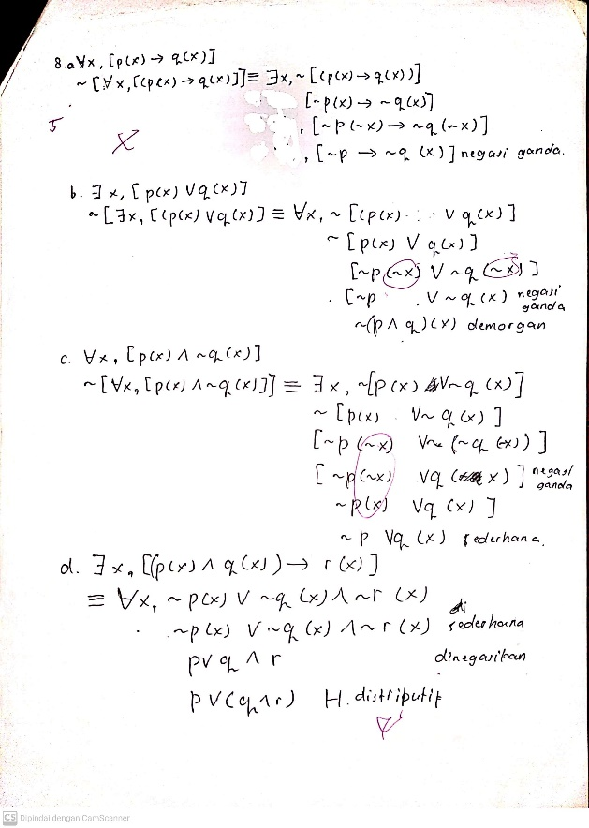
Q1
Q2
Q3
Q4
Q5
Figure 1. One of the student's Work Results on Indicator 1

Then, the error made by the student was a procedural error in carrying out the requested negation operation (see Q4). In this error, students forgot several steps in the process. Of course, this would be causing errors in the next steps. So, the next step taken would be also wrong. This also might be caused by the student's carelessness in addition to a lack of understanding regarding the concept of the operation being given. Next, the error made was an error in describing the distributive law from logical operations, where the form shown was a distributive law, even though it was not (see Q5).
In the second indicator, i.e. classifying an object based on whether or not the requirements of a concept were fulfilled, 13 students from the natural science major answered correctly, and 22 students answered incorrectly. In the group of students from the Social Sciences major, 3 students answered correctly, and 2 students answered incorrectly. Then, in the group of students from the Religion major, all students could not answer correctly. Meanwhile, in the group of students from vocational majors, one student answered correctly. A common mistake students made was identifying the statement '1,000,000,000 is a very large number' as not being a statement. Even though both are statements, their truth value is wrong. This probably happened because students did not understand the concept of statements and truth value, so they assumed that a false statement ( of truth value) was not a statement. Examples of student work results are shown in Figure 2.

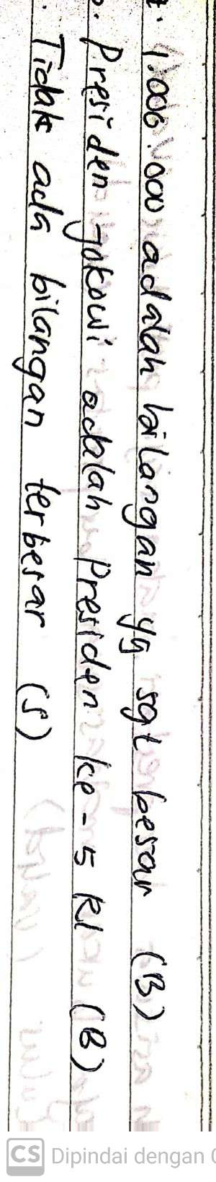
Figure 2. One of the student's Work Results on Indicator 2

Furthermore, in the third indicator, i.e. providing examples or non-examples of a concept, 18 students from the natural science major answered correctly, while 17 students answered incorrectly. Then, for the students from Social Sciences, 2 students answered correctly, while 3 others answered incorrectly. For students from the Religion major, one student answered correctly, and the other answered incorrectly. Meanwhile, all students from the Vocational school could not answer correctly. The mistake that is often made is not being precise in translating logical operations into language correctly. The majority of students' mistakes do not mention 'if' even though the operation given was the implication. An example of work is shown in Figure 3.

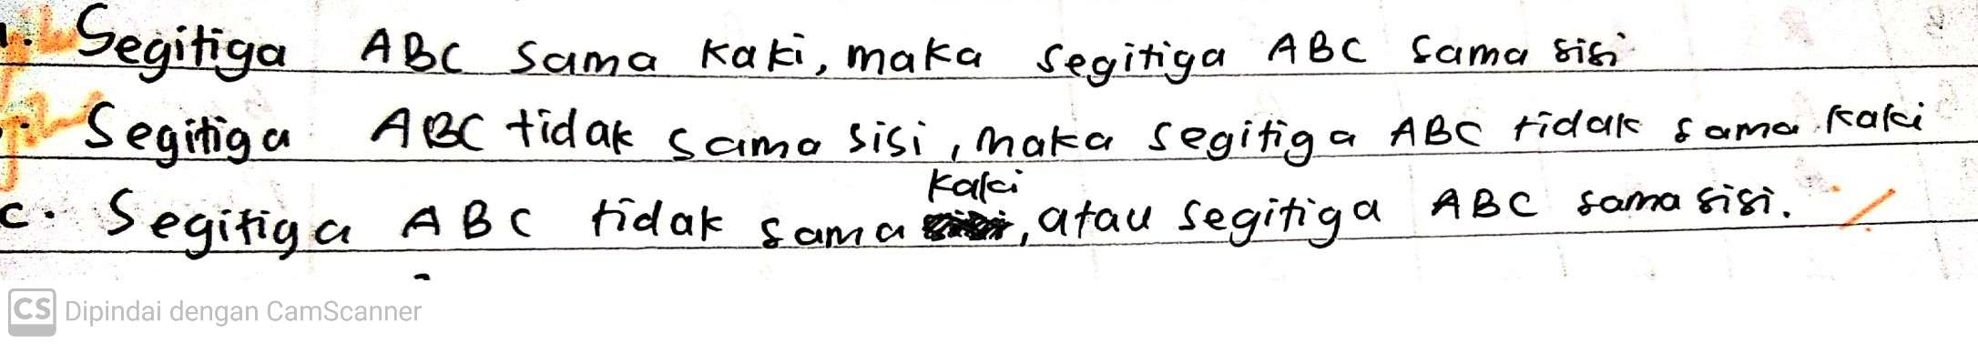
Figure 3. One of the student's Work Results on Indicator 3

In the fourth indicator, i.e. connecting related concepts, as many as 35 students from the natural science major were able to answer correctly in point (a) and could conclude that the tautological implication operation was also a logical implication. Then, in the group of students from the Social Sciences major, 3 students answered correctly, 2 others answered incorrectly, and in the Religion and Vocational groups 1 student in each major answered correctly. The method used by all students to show that these two statements are tautologies was using a truth table. Common errors that occur are due to operational errors. Examples of student work results are shown in Figure 4.
In Figure 4, students were not precise in carrying out operations according to the questions given, resulting in errors in the final results. This error might be caused by students’ carelessness in their work.

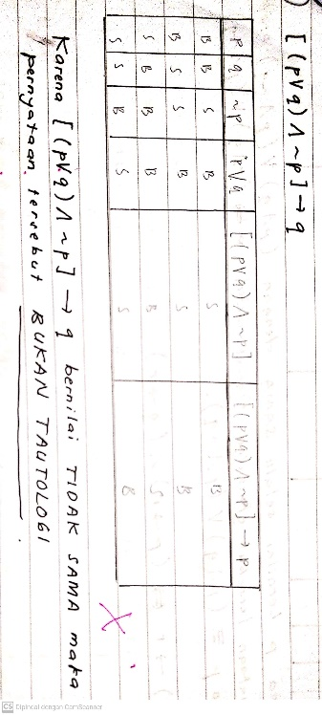
Figure 4. One of the student's Work Results on Indicator 4

In the fifth indicator, i.e. representing a concept differently, 29 students from the natural science were able to answer correctly, and the remaining answered incorrectly. Based on the analysis, the majority of the method used by students to prove equivalence was by using a truth table, while 3 out of 6 students who answered incorrectly, proved it by using the laws of logic as shown in Figure 5.

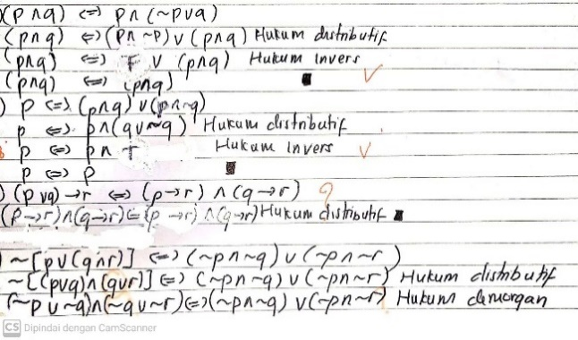
Q1
Q2
Q3
Figure 5. Student Work Results on Indicator 5

Based on Figure 5, in points (a) and (b) students could still do their work correctly through the use of the logical low method. Students could work correctly procedurally, but they were still not quite right when viewed from the aspect of mathematical communication. This was because students did not explain what they wanted to show through the work steps. Then, in point (c) students' work was on the wrong basis (see Q1) because there is no distributive law for the logical operation of implication. In point (d), the student made a procedural error in carrying out the logical operation of distributive law, i.e. $p∨(q∧r)$ which should be equivalent to $(p∨q)∧(p∨r)$. Of course, this would have an impact on the final result that would be wrong (see Q2 and Q3) even though the basis for choosing the Logic Laws used was correct (de Morgan's Laws). Even though this student worked differently from the majority of students, of course, this was not a problem because there are no provisions regarding the choice method of solution, as long as the student can connect the concepts of logical operations, logical equivalence, and logical laws correctly both conceptually and procedurally. This can also be a basis for analyzing the student's creativity in carrying out mathematical operations.
Then, from the group of Social Sciences major students, 3 students answered correctly, and 2 others answered incorrectly. Based on the analysis, all students from the Social Sciences department proved using truth tables with procedural errors in the majority. Then, from each group of Religion and Vocational major students, one student answered correctly, while the others answered incorrectly. The method used by students to show logical equivalence was a truth table by making procedural errors.
In the sixth indicator, i.e. developing necessary or sufficient conditions for a concept, only 2 students from the natural science major answered correctly, and the others answered incorrectly. All those from Social Science, Religion, and Vocational majors answered incorrectly on this indicator. An example of student work is shown in Figure 6.

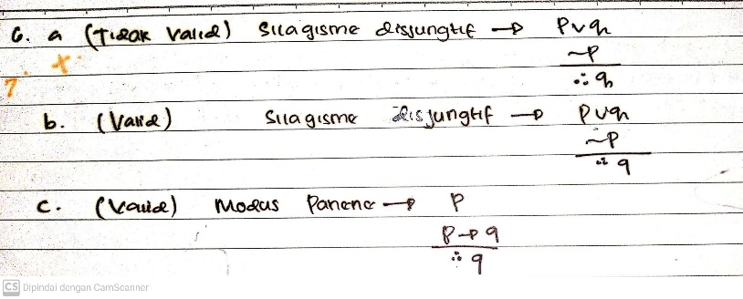
Figure 6. Student Work Results on Indicator 6

Based on Figure 6, the student's error was in point (a) which states that the statement is invalid based on the disjunctive syllogism, even though it should still be valid. The next error in point (c) was that 33 students also answered 'valid based on Modus Tolens rules' as done by the students in Figure 6, even though this statement should not be able to be drawn to a conclusion because it does not comply with the Modus Tolens inference rules. In Figure 6, it also appears that the basis of the student's argument was not the concept of inference rules, because the basis used should be Modus Tolens, not Modus Ponens. This indicated that students had not mastered the sufficient or necessary conditions for concluding (especially Modus Tolens).
Based on the analysis that has been carried out, it was found that the conceptual understanding of Mathematics Education of IAIN Ponorogo students in the first batch of Academic Year 2022-2023 was considered still low. This is shown by the average score obtained in working on conceptual understanding questions in logic material was only 63.13. These results strengthened research that has been carried out on mathematical conceptual understanding at the higher education level which also shows low conceptual understanding (Gusmania & Agustyaningrum, 2020; Hayati & Asmara, 2021; Hoiriyah, 2019; Rosyidah et al., 2021). Referring to the results of this research, we needed more effort to increase students' mathematical conceptual understanding, especially in logical material (Romadiastri, 2016).

CONCLUSION
Based on the research, it was found that the conceptual understanding of the first class of Mathematics Education students at IAIN Ponorogo Academic year 2022-2023 was considered still low with a 63.13 average score.
If we look at the basic major at the previous education level (middle school level), it was found that the average percentage of attainment of conceptual understanding indicators i.e. for natural science major students had the highest average percentage, that is 52.3%. Then, students from the social sciences major had an average achievement percentage of 43.3%. The lowest, students from the Religion and Vocational majors each obtained an average percentage of achievement of indicators of understanding the same concept, which was 33.3%. Thus, the results obtained were that the conceptual understanding of students from science majors was higher than the conceptual understanding of students from non-science majors. This finding confirms previous findings which also stated that the learning outcomes of the Basic Introduction to Mathematics course for students from the science major were better than the learning outcomes of the Introduction to Basic Mathematics course from non-science majors (Parhaini, 2017).
Furthermore, looking at the conceptual understanding indicators, we obtain the findings i.e: (1) in indicator 1 the average percentage of achievement was 45.75%, (2) in indicator 2 it was 36.75%, (3) in indicator 3 it was 35.25 %, (4) in indicator 4 is 65%, (5) in indicator 5 is 60.75%, and (6) in indicator 6 is 1.5%. Thus, it was found that the highest average percentage of achieving conceptual understanding was 65% in indicator 4 and only 1.5% in indicator 6.
Thus, it was found that the major from the previous education level may also influence students' conceptual understanding. This is due to differences in learning load and coverage of material studied when learning mathematics at previous education levels (Parhaini, 2017). This major difference is considered to contribute to differences in students' prior knowledge. So, it will impact learning success at the next stage.
Based on the research findings, suggestions are given to the lecturers to carry out a diagnostic analysis regarding the major of students’ previous education level before carrying out lectures to determine the educational background as a consideration of students' prior knowledge. Considering that mathematics is a branch of science whose subject matter is interrelated, the origin of this major needs to be considered by lecturers in organizing lecture activities to facilitate the needs of each student from different educational backgrounds.
The findings of this research can also be used as a reference for further researchers to study other factors that influence students' mathematical conceptual understanding. As well as conducting comparative research related to students' mathematical conceptual understanding in terms of majors at the previous level.
REFERENCES
Ababil, F. R. U., & Septianawati, E. (2021). Analisis Kecenderungan Mahasiswa Tadris Matematika dalam Memilih Aplikasi Belajar Berbasis E-Learning berdasarkan Minat Belajar. Factor M, 4(1), 21. https://doi.org/10.30762/factor-m.v3i2.3226
Anugrahana, A. (2020). Analisis Kemampuan Pemahaman Kognitif Dan Kesulitan Belajar Matematika Konsep Logika Dengan Model Pembelajaran Daring. Scholaria: Jurnal Pendidikan Dan Kebudayaan, 11(1), 37–46.
Barham, A. I. (2020). Exploring in-service mathematics teachers’ perceived professional development needs related to the strands of mathematical proficiency (SMP). Eurasia Journal of Mathematics, Science and Technology Education, 16(10). https://doi.org/10.29333/EJMSTE/8399
Corrêa, P. D., & Haslam, D. (2020). Mathematical proficiency as the basis for assessment: A literature review and its potentialities. Mathematics Teaching-Research Journal, 12(4), 3–20.
Ernest, P., Skovsmose, O., Van Bendegem, J. P., Bicudo, M., Miarka, R., Kvasz, L., & Moeller, R. (2016). The philosophy of mathematics education. Springer Nature.
Gusmania, Y., & Agustyaningrum, N. (2020). Analisis Pemahaman Konsep Matematis Mahasiswa pada Mata Kuliah Trigonometri. Jurnal Gantang, 5(2), 123–132. https://doi.org/10.31629/jg.v5i2.2493
Hanifah, H., & Abadi, A. P. (2018). Analisis Pemahaman Konsep Matematika Mahasiswa dalam Menyelesaikan Soal Teori Grup. Journal of Medives : Journal of Mathematics Education IKIP Veteran Semarang, 2(2), 235. https://doi.org/10.31331/medives.v2i2.626
Hayati, R., & Asmara, D. N. (2021). Analisis Pemahaman Konsep Matematis Mahasiswa PGSD pada Mata Kuliah Konsep Dasar Matematika. Jurnal Basicedu, 5(5), 3027–3033. http://dx.doi.org/10.31004/basicedu.v5i5.976%0Ahttps://jbasic.org/index.php/basicedu/article/viewFile/976/pdf
Hoiriyah, D. (2019). Analisis Kemampuan Pemahaman Konsep Matematis Mahasiswa. Logaritma: Jurnal Ilmu-Ilmu Pendidikan Dan Sains, 7(01), 123. https://doi.org/10.24952/logaritma.v7i01.1669
Irawan, B. P. (2018). Kecakapan Matematis (Mathematical Proficiency) Siswa dalam Pembelajaran Open-Ended di Sekolah Menengah Pertama. Jurnal Perspektif Pendidikan, 12(1), 60–71. http://ojs.stkippgri-lubuklinggau.ac.id/index.php/JPP60
Karim, A., & Nurrahmah, A. (2018). Analisis Kemampuan Pemahaman Matematis Mahasiswa Pada Mata Kuliah Teori Bilangan. Jurnal Analisa, 4(1), 179–187. https://doi.org/10.15575/ja.v4i1.2101
Karso. (2014). Matematika Dasar 1. Universitas terbuka.
Kholid, M. N., Imawati, A., Swastika, A., Maharani, S., & Pradana, L. N. (2021). How are Students’ Conceptual Understanding for Solving Mathematical Problem? Journal of Physics: Conference Series, 1776(1). https://doi.org/10.1088/1742-6596/1776/1/012018
Lubis, A. R., Khoirunisak, A., Oraple, G., & Pusawidjayanti, K. (2021). Kesalahan mahasiswa dalam menyelesaikan soal kostruksi dasar geometri. Prosiding SNMP, 202–211.
Musyadad, V. F. (2021). Analisis Kesalahan Mahasiswa PGMI dalam Menyelesaikan Soal Matematika Menurut Teori Kastolan. Jurnal Edumaspul, 5(1), 203–207.
Nugraheni, Z., Budiyono, B., & Slamet, I. (2018a). The impact of rigorous mathematical thinking as learning method toward geometry understanding. Journal of Physics: Conference Series, 1013(1). https://doi.org/10.1088/1742-6596/1013/1/012121
Ababil, F. R. U., & Septianawati, E. (2021). Analisis Kecenderungan Mahasiswa Tadris Matematika dalam Memilih Aplikasi Belajar Berbasis E-Learning berdasarkan Minat Belajar. Factor M, 4(1), 21. https://doi.org/10.30762/factor-m.v3i2.3226
Nugraheni, Z., Budiyono, B., & Slamet, I. (2018b). Upgrading geometry conceptual understanding and strategic competence through implementing rigorous mathematical thinking (RMT). Journal of Physics: Conference Series, 983(1). https://doi.org/10.1088/1742-6596/983/1/012121
Parhaini. (2017). Pengaruh Asal Sekolah dan Jurusan Trhadap Hasil Belajar Pengantar Dasar Matematika Mahasiswa Fakultas Tarbiyah UIN Mataram. Hikmah, 13(2), 177–198.
Rismawati, M., & Hutagaol, A. S. rejeki. (2018). ANALISIS KEMAMPUAN PEMAHAMAN KONSEP MATEMATIKA MAHASISWA PGSD STKIP PERSADA KHATULISTIWA SINTANG Melinda. Jurnal Pendidikan Dasar PerKhasa, 4(1), 91–105. http://forschungsunion.de/pdf/industrie_4_0_umsetzungsempfehlungen.pdf%0Ahttps://www.dfki.de/fileadmin/user_upload/import/9744_171012-KI-Gipfelpapier-online.pdf%0Ahttps://www.bitkom.org/ sites/default/files/ pdf/Presse/Anhaenge-an-PIs/ 2018/180607 -Bitkom
Romadiastri, Y. (2016). Analisis Kesalahan Mahasiswa Matematika Dalam Menyelesaikan Soal- Soal Logika. Phenomenon : Jurnal Pendidikan MIPA, 2(1), 76. https://doi.org/10.21580/phen.2012.2.1.419
Rosyidah, U., Setyawati, A., & Qomariyah, S. (2021). Analisis Kemampuan Penalaran dan Kemampuan Pemahaman Konsep Matematis Mahasiswa Pendidikan Matematika Pada Mata Kuliah Aljabar Dasar. SJME (Supremum Journal of Mathematics Education), 5(1), 63–71. https://doi.org/10.35706/sjme.v5i1.4488
Sudiarta, I. G. P., & Widana, I. W. (2019). Increasing mathematical proficiency and students character: Lesson from the implementation of blended learning in junior high school in Bali. Journal of Physics: Conference Series, 1317(1). https://doi.org/10.1088/1742-6596/1317/1/012118
Wahyuni, I., & Kharimah, N. I. (2017). Analisis Kemampuan Pemahaman dan Penalaran Matematis Mahasiswa Tingkat IV Materi Sistem Bilangan Kompleks pada Mata Kuliah Analisis Kompleks. JNPM (Jurnal Nasional Pendidikan Matematika), 1(2), 228. https://doi.org/10.33603/jnpm.v1i2.608

Conflict of Interest Statement: The authors declare that the research was conducted in the absence of any commercial or financial relationships that could be construed as a potential conflict of interest.
Copyright © 2023 Zahra Nugraheni, Sofwan Hadi. This is an open-access article distributed under the terms of the Creative Commons Attribution License (CC BY). The use, distribution or reproduction in other forums is permitted, provided the original author(s) and the copyright owner(s) are credited and that the original publication in this journal is cited, in accordance with accepted academic practice. No use, distribution or reproduction is permitted which does not comply with these terms.

